Nexus Repository Manager Installation Process

Step 1:-

Download Nexus Repository Manager latest version from below given link

Link:- <https://help.sonatype.com/repomanager3/download>

Step 2:-

Installation Method guid link

Link:- <https://help.sonatype.com/repomanager3/installation/installation-methods>

Path:-C:\Program Files\nexus-3.32.0\nexus-3.32.0-03\bin

Command :- *nexus.exe /run*

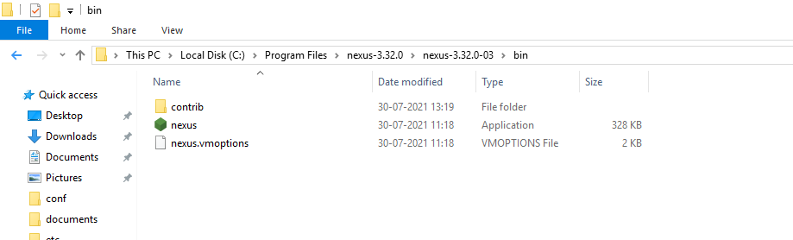

Step 3:-

Default ID=admin and temporary password generated at below path

Path:- C:\Program Files\nexus-3.32.0\sonatype-work\nexus3\admin.password

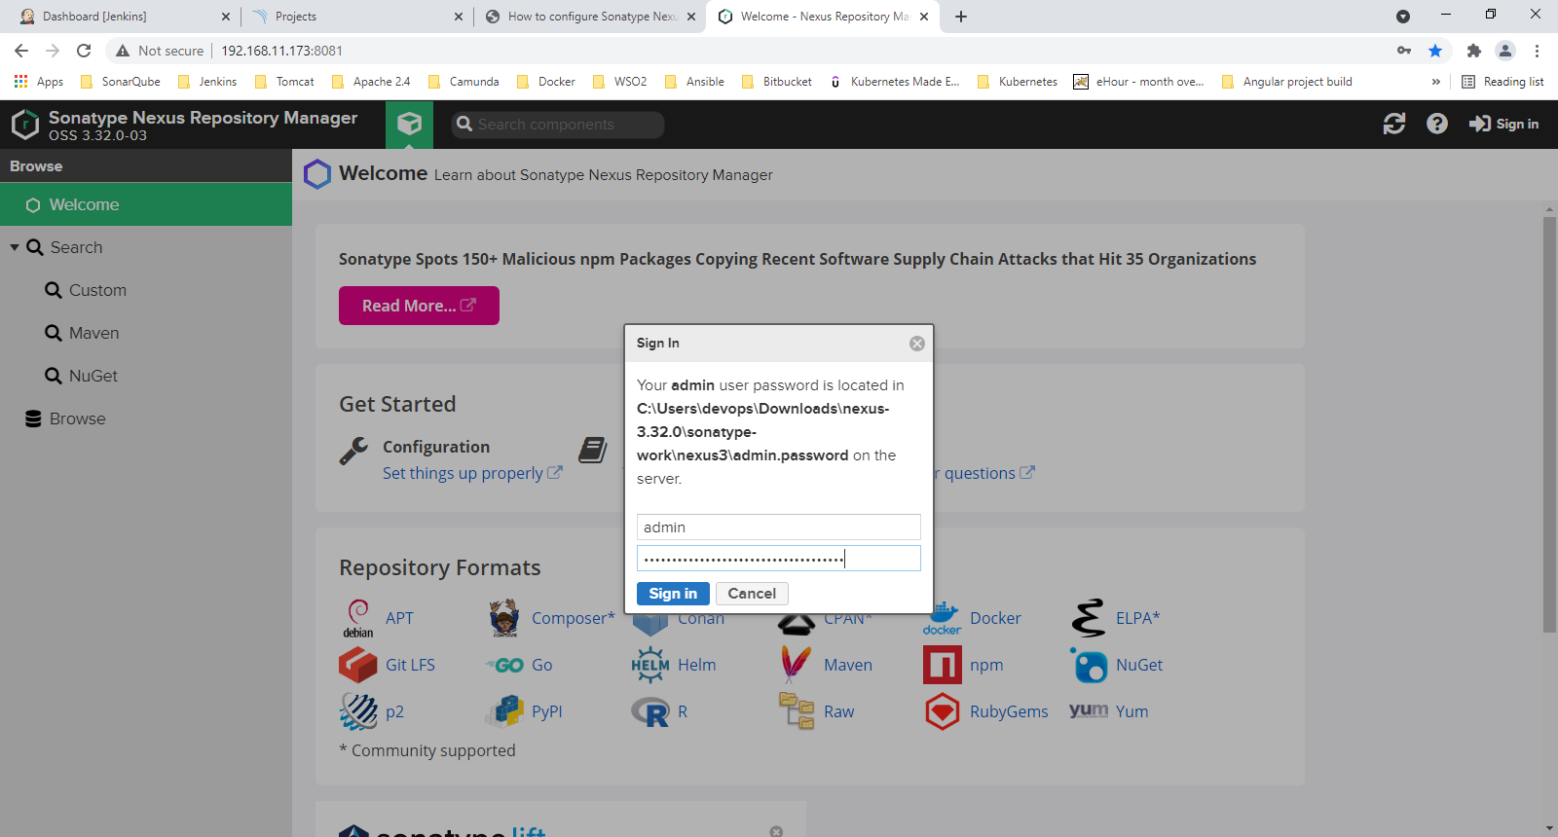

Then you need to change password.

